Best Practice
for Coupons & Vouchers

September 2013

Endorsed by:

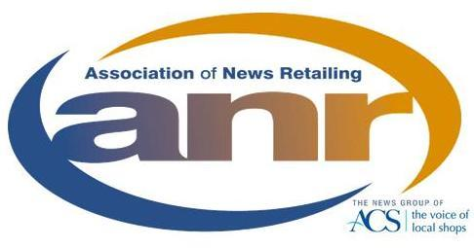

CONTENTS

Page

Introduction 4

Who has endorsed the Best Practice? 5

Who Should Read It? 5

Now read on!! 5

Setting the Scene - Coupon Activity, Basic Facts 6

THE VALUE CASE FOR VOUCHERS IN THE NEWSTRADE

The Value Case for Vouchers in the Newstrade 8

The Voucher Scheme Operations Process 9

The Voucher Redemption Process 10

Risks 12

The Hierarchy of Risks 13

The Call to Action – Strengthening the Voucher Case 14

Industry Choices & Opportunities 15

THE BEST PRACTICE

Magazine Vouchers Technical Guidance 17 (1…)

PPA Publishers Smart Guide to Voucher Scheme Safety 34

PPA Top Ten Tips for Magazine Vouchers 36

PPA Retailer Smart Guide to Vouchers 37

‘Spot the Danger Signs’ – Processing Alerts 38

Developing a Feedback Loop with Voucher Processers 39

INFORMATION SOURCES, CONTACTS, LINKS 40

INTRODUCTION

Promotional coupons & vouchers are valuable marketing tools for magazine publishers. There has been steady growth in their usage in the period 2006 – 2010. Latest figures for 2010 indicate that some 537million vouchers were redeemed. There has been a large increase in coupons used among 55-64 year olds which is a clear signal to adapt promotions to appeal to the mature consumer. The total value of coupons redeemed was just under £500 million (£499m), a dramatic rise of 25% on the previous year. In recent years a number of challenges have also become evident and these need to be fully understood and addressed to ensure that added value for all stakeholders continues to be delivered against publishers investment.
Coupon and voucher downloads continue to grow in popularity with 22% stating that they
have used a voucher/coupon found on the internet over the last 12 months.

The Voucher Best Practice is presented in two parts. The Value Case for Vouchers describes the processes and risks associated with running successful campaigns. It also states the case for strengthening the voucher cause and offers practical suggestions to maintain the position for the future. The Best Practice summarises existing guidance to all members of the voucher value chain specifically indicating the target audience of readers. Guidelines have been prepared to assist publishers, distributors, wholesalers, retailers and processing houses’ understanding of running successful promotional schemes.

Looking to the future the newstrade is faced with a number of challenging decisions to ensure that coupons and vouchers retain their importance in the promotional armoury and therefore continue to drive sales for the benefit of all. The choices and strategic opportunities which need to be addressed are summarised on page 15. These will form the basis of future activity, generating a range of work streams to address the issues head-on.

UPDATED: November 2011

WHO HAS ENDORSED THE BEST PRACTICE?

The Voucher Best Practice has been compiled by a cross-industry working group comprising members of the Professional Publishers Association (PPA), wholesaler and retailer representatives and executive members of the Institute of Promotional Marketing (IPM), whose technical knowledge and support has been invaluable. Consultation has also taken place with coupon redemption houses. All organisations have given their full endorsement and further support is currently being sought from retail trade associations.

WHO SHOULD READ IT?

It is intended that this document be read and used by:
- circulation, operations and copy design teams of magazine publishers and distributors
- operational directors and managers of wholesalers, independent and multiple retailers
- key managers at voucher processing houses
- Directors and advisory staff at trade associations supporting all Newstrade interests.

It is also anticipated that a range of users who access information from the National Title File will benefit from understanding the principles involved.

NOW READ ON!!

The following pages are designed to give a comprehensive over-view of:
Key industry trends in coupon/voucher activity
The value case for promotional vouchers in the Newstrade
Scheme operational & redemption processes
Risks & danger signs and how to deal with them
Opportunities for the future
The Best Practice for all those involved in Newstrade Voucher schemes
Information Sources, Contacts and Internet Links
Setting the Scene - Coupon Activity, Basic Facts

The latest data reported in 2011

537 million vouchers redeemed in the UK in 2010. The total value of vouchers redeemed amounted to £500 million (£499m), a dramatic rise of
25% on the previous year.

39% of all vouchers issued are distributed in Newspapers & Magazines
By far the largest distribution method

12% of all redeemed vouchers are from newspapers & magazines
By far the largest single redemption category

61% of consumers use coupons (up from 52% in June 2010), 24% stated that they use coupons more frequently.

22% of consumer’s state that they have used a voucher found on the internet over the last 12 months showing the internet continues to grown in popularity.

29% of the 65+ age group stated they were looking out more for promotional offers than a year ago (16% in June 2010).

Source: Valassis

THE VALUE CASE FOR VOUCHERS
IN THE NEWSTRADE

The Value Case for Vouchers in the Newstrade

The Voucher Scheme Operations Process

The Voucher Redemption Process

Risks

The Hierarchy of Risks

The Call to Action – Strengthening the Voucher Case

Industry Choices & Opportunities

THE VALUE CASE FOR VOUCHERS IN THE NEWSTRADE

Coupons and vouchers serve as excellent strategic tools for magazine sales promotion. They can offer opportunities for promotional discounts, incentivising customers to sample new title launches, revisit old favourites or extend reading horizons. They can be an effective way of building circulation loyalty and supporting titles at times of product ‘re-positioning’.

The value case for vouchers in the newstrade is founded on many perceived benefits, reinforcing the massive value of £7.2m RSV spending which passes through the news trade each week.

Coupons and vouchers fulfil a number of important marketing objectives:

- They provide customers with perceived added value
- Drive footfall into stores
- Increase market penetration
- Attract new customers
- Increase sales
- Introduce new products
- Encourage brand loyalty
- Re-activate lapsed consumers
- Enter new markets
- Support products at point of sale
- Draw attention to the title/brand
- Counteract competitor activity
- Encourage repeat purchase & brand loyalty
- Reduce excessive stock levels
- Encourage ‘trading up’ to higher priced products
- Cushion the impact of price increases
- ‘Shape’ customer behaviour
- Collect valuable personalised consumer data
- Influence the shopper at the shopping list stage

Coupon & voucher schemes are:

- Quick & easy to arrange
- Trackable
- Versatile
- A good basis for data collection

And … Customers like using coupons & vouchers

UK manufacturers issue nearly 5 BILLION coupons every year -
Acting as a major UK promotional tool

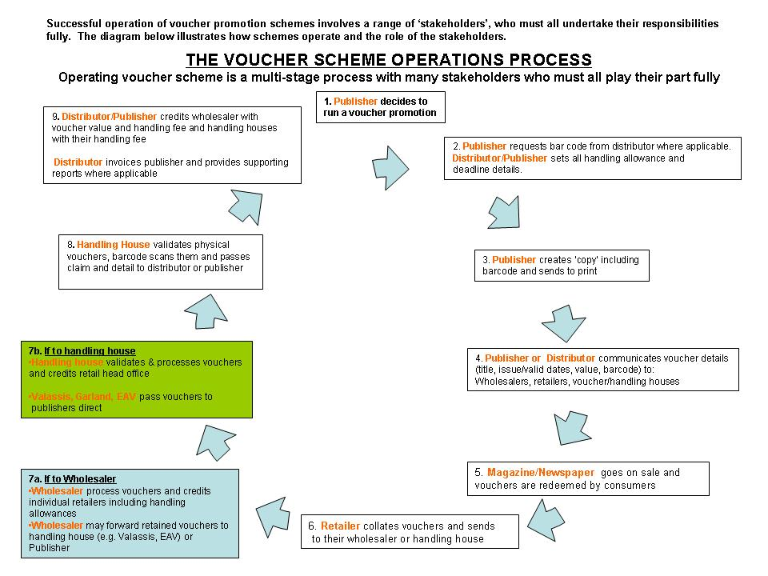
Scenario 1 – Redemption via Independent Retailer
- Consumer redeems voucher with retailer
- Retailer sends voucher to wholesaler and receives credit
- Wholesaler sends voucher to Handling House and receives credit
- Handling House counts and charges either Publisher or Distributor and provides redemption figures
- Handling House can return physical vouchers to Distributor and Publisher on request
- Publisher or Distributor credits Handling House

Scenario 2 – Redemption via FSO Handling House to Distributor
- Consumer redeems voucher with retailer
- Retailer sends voucher to Full Service Option Handling House and receives credit
- Handling House counts and charges either Publisher or Distributor and provides redemption figures
- Handling House can return physical vouchers to Distributor and Publisher on request
- Publisher or Distributor credits Handling House

Scenario 3 – Redemption via Retail Affidavit

(Tesco – non paid)
- Consumer redeems voucher with Tesco
- Tesco destroys redeemed vouchers
- Tesco Data Agent provide store level redemption data to Distributor or Publisher
- Distributor or Publisher validates redemption and credits Tesco

Nb – If optional voucher fee is paid by publisher, redemption validation is provided by Tesco

Scenario 4 – Redemption via Handling House to Publisher
- Consumer redeems voucher with retailer
- Retailer sends voucher to Handling House and receives credit
- Handling House counts and charges either Publisher or Distributor and provides redemption figures
- Handling House can return physical vouchers to Distributor and Publisher on request
- Publisher or Distributor credits Handling House

RISKS

Despite their value as important means of sales promotion all voucher schemes carry a degree of risk. Publishers should be aware of potential risks in order to improve their decisions on the most appropriate form of vouchering to achieve maximum impact at minimum risk.

- Mis-redemption – Customers redeem vouchers against something other than the product stated on the voucher

- Mal-redemption – Attempts to fraudulently profit from multiple redemption of vouchers when no purchase has been made.

E.g.: Multiple high value vouchers clipped from low value media and submitted for bulk redemption.

- Manipulation – Some online downloadable vouchers may be manipulated by ‘cut & paste’ software to change the bar code, making it scan for a higher value than the promotional message suggests or direct redemption costs to another issuer.

Voucher processing houses are briefed to be vigilant for attempts at mal-redemption and refer instances to brand owners for further investigation. Payment to claimants may be withheld pending further investigation.

- Coupons as Cash – Certain websites offer advice to users on how to use coupons as cash. The redemption policies of the major supermarket groups have recently been changed to require that promoted products must be purchased before vouchers can be redeemed.

- Coupons for Sale – In common with many other products, bulk quantities of newstrade vouchers are sometimes offered for sale to the highest bidder on well known online auction websites. These may be out of date or invalid vouchers. Attempts to redeem them through retailers may result in them being disadvantaged if vouchers are rejected by clearing houses.

Efforts by the Institute of Promotional Marketing, PPA and some media owners have achieved some important progress. Please see ‘The Call to Action’ (page 14).
The Hierarchy of Risks for different types of Voucher Schemes

All types of voucher schemes have risks attached. As a general rule, the less well the target market is defined and addressed, the greater the risk.

The table below shows the types of risk inherent with various approaches to vouchering.

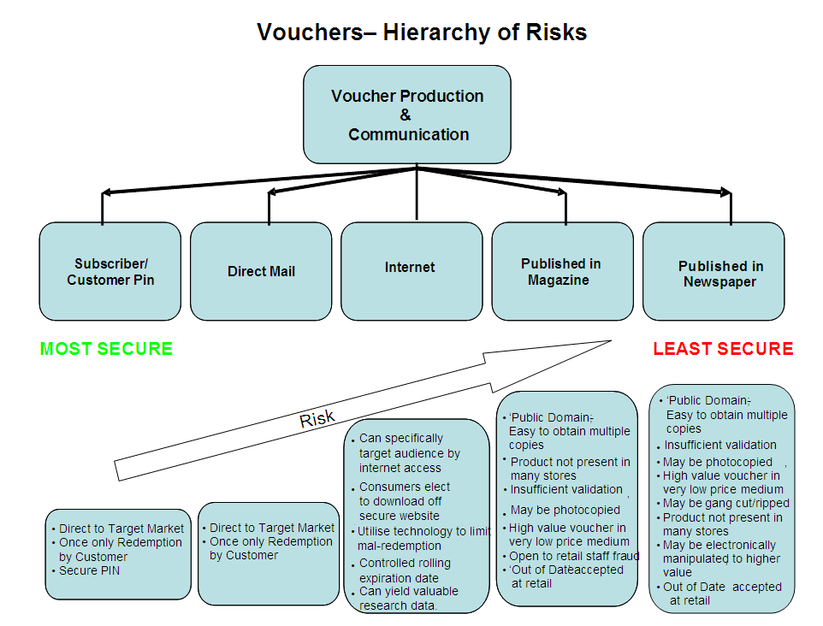

NOTES

INTERNET ‘ONLINE’ VOUCHERS
There has recently been considerable growth in the range of ‘secure’ online vouchering methods. These range from secure vouchers which may be downloaded and printed once only to downloadable codes onto mobile phones which may then be used at payment terminals. There have also been developments with unique barcodes which enable each coupon to be tracked and linked to a specific consumer.

Voucher schemes may also be ‘insured’ against over-redemption to protect against excessive take-up.

It is not the purpose of this document to recommend individual suppliers, but issuers wishing to use these strategic approaches should research available options via their marketing departments or the internet.

FREE PUBLICATIONS
Publishers should exercise caution if considering the use of free newspapers and magazines to issue vouchers. These media present a significantly higher risk of mal-redemption through illicit “clipping” of vouchers from unused copies.

THE CALL TO ACTION – STRENGTHENING THE VOUCHER CASE

- Coupons and vouchers are a powerful marketing tool. However, their potential is compromised by mis and mal-redemption which costs marketers over £20M annually (source; Institute of Promotional Marketing).

- Misredemption is a continuing threat and has more than doubled in the last five years.

- The fierce competition for customers in the grocery retail sector has in the past resulted in misredemption of some types of vouchers. For example where one supermarket offers to redeem vouchers issued by a competitor.

- Over the last ten years the Institute of Promotional Marketing (IPM) has been asked repeatedly by many members to assist in eliminating consumer misredemption. IPM represents the interests of a wide range of major manufacturers, retailers and media owners.

- On behalf of its 220 members the IPM is obliged to protect coupons and vouchers as valuable marketing tools. They remain the strongest independent price promotion technique at marketers' discretion.

- IPM intends to minimise and ultimately eradicate the waste caused by coupon misredemption, and to restore this marketing tool to its full potential

- IPM’s Strategies are to:
  - Coordinate the views and interests of different stakeholders and broker progress in a co-operative manner
  - Facilitate a practical approach to minimising misredemption in the short-term, whilst promoting progress towards system-based solutions in the medium & long-term
  - Ensure adequate project support and funding

- A number of tactics and measurement approaches are currently being discussed to achieve and quantify:
  - Declines in the volume & value of mis and mal-redemption
  - Amendment of consumer perceptions towards mis and mal-redemption
  - Restored growth in the use of coupons & vouchers by manufacturers, retailers and media owners

Some important progress has been achieved through the IPM’s efforts to date.

In June 2009 eBay introduced a Manufacturers Vouchers Policy.

New rules state that electronically scanned coupons will not be permitted for sale. All coupons and vouchers sold through eBay must be physically delivered to the buyer and not sent by electronic means for home printing. eBay also asks sellers not to place clear, unaltered scans of coupons and vouchers in their listings that could be copied, printed and redeemed.

Bulk coupon and voucher sales are also disallowed. Such listings are defined as those offering more than 20 coupons or vouchers for the same item or more than 100 in total. Coupon and voucher inserts taken from newspapers are limited to five per listing.

Supermarket Activity
At the time of publishing major supermarkets continue to tighten their policies on coupon and voucher redemption. There is a growing requirement that coupons may only be redeemed if the promoted product has been purchased. Activity continues to persuade retailers operating a ‘coupons for cash’ policy to come in line with industry leaders.

INDUSTRY CHOICES AND OPPORTUNITIES

Strategic new approaches & safeguards to the traditional routes

Looking ahead, the newstrade must address some searching questions to secure the future of coupons and vouchers as viable promotional tools.

THE CHOICES …

- Do nothing and let the status quo prevail?
Continuing to issue coupons and vouchers while ignoring the current challenges will inevitably lead to a further erosion of credibility. Continued abuse will cause publishers to lose confidence and stop promoting by this means.

All members of the newstrade - publishers, wholesalers and retailers alike - will lose sales.

This is not a credible option!

- Tackle mis & mal redemption on a united industry front?
Progress has already been made in this area with the formation of the Voucher Redemption Group. Initially a PPA initiative the group also draws members from the Association of Newspaper & Magazine Wholesalers (ANMW), the National Federation of Retail Newsagents (NFRN), the Association of News Retailers (ANR) and the Institute of Promotional Marketing (IPM) and voucher processing houses.

The group has presented its case and forward objectives to key newstrade decision-making groups and this Best Practice fulfils an objective to continue the process of combating coupon & voucher mis and mal-redemption. Among its terms of reference the group will work closely with all interested parties to push forward measures to combat malpractice and develop a manifesto to secure the future.

The group is committed to:

- Develop valid measurements and provide transparency of reporting
- Pinpoint the high risk ‘Hot Spots’ and prioritise for action
- Validate processes at retail, wholesale and clearing houses
- Campaign for better practices with all stakeholders
- Work with other interested parties e.g. the IPM
- Identify and deal with repeat offenders
- Propose a ‘certification mark’ for stakeholders operating to required standards

Additionally the group will address a range of practical areas to give guidance to coupon and voucher issuers within the newstrade. For example:

- The choice of appropriate media to distribute coupons
- Face values relevant to the type of promotion and media employed
- Techniques to avoid mal-redemption (where coupons are redeemed prior to reaching the consumer)
- Avoidance of ‘blanket’ distribution for specialist & ‘niche’ products
- Clear statement of the terms of the offer, rules and regulations
- Increasing technological security of vouchers
- Use of retailers own bar codes on retailer specific promotions
- Supplying redemption processing houses with lists of non-eligible stockists to ensure that store returns policies are properly administered

BEST PRACTICE

These sections within the Best Practice summarise existing guidance to all members of the coupon and voucher value chain.

The intended audience for each section is clearly signposted

Appropriate internet links are given wherever possible to ensure accurate and current information is available at all times.

Section Audience Page

Magazine Vouchers Technical Guidance Publishers/Distributors/Wholesalers 1
Retailers

PPA Publishers Smart Guide to Voucher Schemes Publishers/Distributors 34

Top Ten Tips for Magazine Vouchers Publishers/Distributors 36

Retailer Smart Guide to Vouchers Retailers 37

Spot the Danger Signs Publishers/Distributors/Wholesalers/ 38
Processing Houses/ Retailers

Developing Feedback Loops Publishers/Distributors/Wholesalers/ 39
Processing Houses

Information Sources, Contacts, Links Publishers/Distributors/Wholesalers/
Processing Houses/ Retailers 40

Please note the preceding pages aim to provide context to this complicated promotional medium and intend to complement and support the following standards and guidelines.

.Audience - Publishers/Distributors/Wholesalers/ Retailers

                - MAGAZINE VOUCHERS

                - GUIDANCE ON THE DESIGN, PRODUCTION AND PROCESSING WITHIN THE NEWSTRADE

Updated September 2013

CONTENTS

Page

- Introduction, Best Practice Objectives, Scope 3

- Voucher Creation – Checklist 4

- Creating a Voucher? 5
3.1 General Guidance 5
3.2 Internet Vouchers 6
3.3 Voucher Handling Costs 6
3.4 Voucher Size and Shape 6
3.5 Voucher Text 6
3.6 Closing dates 7
3.7 Redemption Periods 7
3.8 Value 7
3.9 Materials 7

- Voucher Bar Codes 8
4.1 Positioning 8
4.2 Structure 8
4.3 PIN Codes 9
4.4 PIN Code Structure 10

- Communication 11

Appendix 1 Standard Voucher Specification 12

Appendix 2 Voucher Notification document 13

Appendix 3 Magazine Publisher / Wholesaler
Standards and Best Practice Agreements 14
Voucher Processing - Magazine Publishers
Wholesaler Best Practice
Press Distribution Code -Voucher Processing
Appendix 4 Voucher Clearing Houses – contact list 16

Appendix 5 Publisher contact list 17

1. Introduction

This document provides guidance for the application of best practice in voucher design and processing. Adherence to these principles will provide a platform for the smooth and efficient processing of vouchers throughout the supply chain.

The guidelines are endorsed by:
- The National Federation of Retail Newsagents (NFRN),
- British Retail Consortium (BRC),
- Professional Publishers Association (PPA) and the
- Association of Newspaper and Magazine Wholesalers (ANMW)
- Association of News Retailing (ANR)

Best Practice Objectives

(a) To create a voucher campaign that is clear to understand for both consumers and retailers
(b) To achieve maximum publisher campaign effectiveness.
(c) To ensure production and processing operates efficiently throughout the supply chain
(d) To achieve Industry Standard (Press Distribution Code) requirements.
(e) To adhere to PPA / ANMW best practice guidelines

Poorly designed vouchers that do not follow best practice create both retailer and, more importantly, reader confusion. This leads to reluctance to redeem, adds considerably to retailer and wholesaler processing costs and reduces the effectiveness of the promotion.

Scope
These guidance notes cover the magazine industry requirements for vouchers that give “money off” a nominated magazine and have been designed to be redeemed through the retail / wholesale / clearing houses. They also outline the requirements for all parties within the supply chain.
Since the introduction of these guidelines in 2004/5 the number of errors generated by non-compliance to these standards has significantly reduced. Your cooperation in ensuring all new vouchers put into the news supply chain by your companies meet these guidelines is greatly appreciated.
One area I would like you all to focus on in 2008 is ensuring vouchers meet the guidelines for size / shape

If you have any comments or questions please contact
Howard Birch,
Tel. 01793 563692
Email howard.birch@smithsnews.co.uk

2. Voucher Creation – Checklist

Confirm the following –

1 The voucher wording is legal, unambiguous and clear for the consumer and retailer to understand.
2 The voucher clearly identifies the cash value, the product and the offer is clear and easily understandable to the retailer and it would therefore be accepted at the till.
3 The consumer redemption date is clearly shown on the front of the voucher
4 The voucher number is correctly compiled and is encoded within the EAN-13 symbol.
5 The size of the bar code symbol, both the magnification and the bar height.
6 There are adequate ‘quiet zones’ for the bar code symbol.
7 Key lines are not surrounding the bar code on the final voucher.

8 That any additional PIN bar codes have been correctly positioned and encode the correct information.

9 That all voucher bar codes scan correctly first time.

10 The retailer redemption period meets the minimum industry requirements

11 The voucher meets the minimum and maximum size requirements.

12 Handling and clearing houses must be notified in advance of voucher campaigns, and additionally should be notified if the voucher is subject to over-redemption insurance cover.
13 That no other printing will obscure the bar code symbol on the finished voucher.
14 The voucher clearing-house must be notified in advance if the additional information needs to be captured or the vouchers need to be retained.

3. Creating a Voucher?

When a voucher is issued consumers, retailers, wholesalers and clearing houses each have requirements to handle it efficiently.
- It must be made clear to consumers what they’re being offered, where the offer can be redeemed and the time duration for the offer.
- Retailers are relied upon to accept vouchers and give consumers the correct saving and it is in the interest of all promoters to ensure that their vouchers can be processed quickly and efficiently by all retailers, wholesalers and clearing houses.
- Anyone responsible for the design and/or issue of a voucher to be redeemed through the retail or wholesale trade should refer to these guidance notes to ensure that their vouchers adhere to the requirements of good design.

3.1 General Guidance

In most instances vouchers are handed to retailers as part of a cash payment and it is, therefore, vital that the cash value is clearly shown on each voucher to prevent confusion at redemption and possible delays at retailer checkouts. Vouchers are often presented to newsagents at busy periods and therefore to ensure retailers' commitment to voucher redemption, the voucher redemption value and validity instructions should be easy to read.
To avoid confusion with permanent and promotional cover price changes, it is recommended that the reduced retail price is not included on vouchers.

Separate vouchers should be issued for each promotional value. Multiple choice/value vouchers should be avoided for the following reasons:-

- They create confusion
- There is a risk of inaccurate completion

Where multiple choice/value vouchers are used, a handling allowance surcharge may be incurred.

Vouchers printed within publications or leaflets, should not have Bar Codes or validity dates too close to cut out lines to avoid damage when cut or torn from the publication.

Where possible, vouchers should be issue specific and only show their "money off" cash value on the front of the voucher.

Whilst it is important for the marketing message to be conveyed, it is important that the voucher itself is unambiguous. The narrative of the pack or surrounding text can employ emotive and powerful messaging "for £1" "half price" but must be easily understood by all levels of staff. So the value of the voucher must be predominant on the voucher itself.

With the exception of the reader redemption validation date (which should be shown clearly on the front of the voucher), redemption instructions should be in small print. Wholesaler redemption instructions are not required on vouchers, as these must be agreed prior to the distribution of the voucher.

Promotional messages should not be included on vouchers to ensure the value and validity message of the voucher is easy to read by both the reader and retailer.
A clear indication around the border of the voucher itself should appear as dotted or "cut" lines.
Also check that the voucher is not printed on the reverse of another voucher, or on the reverse of any other bar code.

3.2 Internet Vouchers

Secure vouchering solutions should be considered to avoid the dangers of fraudulent copying and claims. Further information may be obtained from the key publisher/distributor contacts shown in appendix 5.
3.3 Voucher Handling Costs
Where a promotional scheme takes the form of a voucher that is redeemable through the newstrade the following costs will be incurred:
- A handling allowance for the retailer.
- A handling charge from the wholesaler / voucher clearing house.
These costs should be budgeted for when planning a voucher campaign.
3.4 Voucher Size and Shape
Vouchers should all be of a similar size to ease the handling process at retail, wholesale and clearing houses. Very large or very small vouchers should be avoided as these add to the handling time and to overall process costs.
Rectangular
- Minimum size: 42mm height x 70mm width
- Maximum size: 92mm height x 128mm width

Vouchers that are incorporated into leaflets or other promotional material should be easy to detach, preferably perforated.

3.5 Voucher Text

Vouchers should carry clear instructions to both consumer and retailer on usage and redemption.
Consumer instructions should be worded along the following lines:
Hand this voucher to your newsagent to claim your copy of “The Magazine”. Only one voucher can be used against each item purchased. Please do not attempt to redeem this voucher against any other product as refusal to accept may cause embarrassment and delay at the checkout.
Or
Present this voucher to your news retailer to receive xxp off the cover price of “The xxx” on the date indicated overleaf. This voucher may only be redeemed against a single copy of “The xxx”. Not valid in conjunction with any other offer. Vouchers are not transferable and are not valid outside the UK.

Retailer instructions should be worded along the following lines:
The “Magazine” thanks you for accepting this voucher. Please return this voucher to your wholesaler to receive your credit + handling allowance within X days from the consumer expiry date printed on the front of this voucher, or specific date.
Or
The xxx thanks you for accepting this voucher. Please return it within xx days of receipt (or specific date) to your wholesaler to receive the amount of xxp plus xp handling charge. Notice: this voucher is not transferable. Accepting it in lieu of payment for any other article constitutes fraud.

3.6 Closing dates
Where an offer closing date is applied, this should be clearly and prominently marked using the words “Valid until…”

3.7 Redemption Periods
The consumer redemption expiry date for Magazine issue specific promotions should be a minimum of 4 weeks after the end of the on sale period.

For non-issue specific promotions, the consumer redemption expiry date will be as advised by the publisher on the voucher notification advice. Wholesaler redemption to retailer will be determined by the wholesalers’ final date for credit as advised by publishers on the voucher notification advice. This should be a minimum of 8 weeks after the redemption expiry date.

Min Consumer redemption period 4 wks, 28 days

Min Retail redemption period ... additional 2 wks, 14 days
Min Wholesaler redemption period ... additional 6 wks, 42 days

Total number of days after off sale 12 wks, 84 days

To support reducing retailer shrink, Wholesalers will credit late “Retailers Voucher Returns” providing it is within the wholesaler’s redemption period.

3.8 Value
The sterling value should appear once as a bold figure on the front face.
The words "OFF" should appear in one bold typeface.

3.9 Materials
Vouchers should be printed on durable material of a weight and texture, which is easy to handle without vouchers sticking together or ripping although special care will be needed to ensure that the bar code will scan.

4. Voucher Bar Codes

4.1 Positioning

The size and definition of printed bar codes should follow international standards to ensure detection and "read" by electronic barcode reading equipment.

Bar codes should be placed where they cannot be rendered "unreadable" as a result of a newsagent’s stamp or reader handwriting.
Voucher bar codes where possible must be unique for each promotion.

EAN13 to be at least 19mm high (including the numbers underneath) and 21mm across with the number printed beneath it.
EAN13 must have a clear white space around it of 2mm on the left and right and 1mm at the top and the bottom.
The EAN13 is to be printed black on a white background.
The value encoded in the bar code should be the same as the face value of the voucher
This includes the light margins that surround the bar code, and are safeguarded by the leading digit 9 on the left hand side and the light margin chevron on the right hand side. Key lines should not be printed near the bar code as they may cause difficulties when the bar code is scanned. The bar code, including its surrounding light margins, should be located at least 4mm from the base and right hand edge of the voucher.
Please note that the magnification range for EAN symbols is from 80% to 200%. The minimum magnification factor that can be used depends on the printing method and substrate. Using a magnification factor smaller than the print quality can sustain, will impact on the ability to scan.
It is recommended that a scanning quality check should be made on all bar codes during production to ensure they read correctly first time.
4.2 Structure
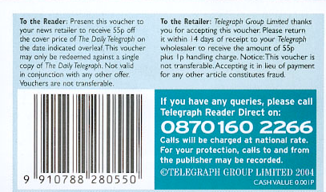
The use of EAN 13 bar codes is essential to enable prompt and efficient processing of vouchers through the supply chain. Voucher Bar Codes have a different structure to publication Bar Codes and require a voucher issuer number that can be obtained from GS1 UK Staple Court, 11 Staple Inn Buildings, LONDON, WC1V 7QH. Tel: 020 7092 3500, Email: info@gs1uk.org. N.B. Numbers are only issued to member companies.) An issuer is allowed up to 1000 vouchers before another number is required.
A new voucher barcode must be allocated for each new voucher value and/or redemption period. Voucher barcodes and reference numbers must not be reused within a 36 months period.

The code for use in the UK is as follows: 99 YYYY NNN VVV C
99YYYY is the voucher issuer number;
NNN is the voucher reference number;
VVV is the redemption value
C is the check digit.
Voucher reference numbers are used to identify individual voucher promotions. Every different voucher promotion, redemption and validity period should be allocated a different number.
Voucher reference numbers may be re-used 36 months after the issue of the voucher with that number.
The redemption value of the voucher is directly represented from 1p (VVV = 001) to £9.98 (VVV = 998). For values greater than £9.98 the code 999 is used and the redemption value is key-entered at the checkout.
Different voucher reference numbers must be allocated when there is any change to the:
Face value; Expiry date; or Promotion;
The Issuer number changes when the brand owner changes. All future vouchers issued should use the new brand owner’s Issuer Numbers. Failure to do so could incur costs on both parties.

4.3 PIN Codes

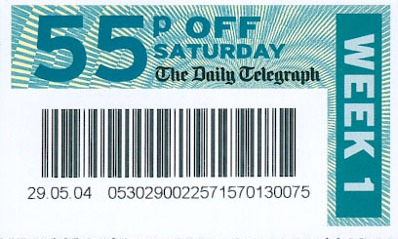

Additional bar codes can be added to the voucher to provide more information for either the manufacturer, retailer or voucher clearing house or all parties. This information is usually encoded in a PIN bar code.
The additional bar code can be used to track the promotion, tie the voucher back to information in a database or to identify specific information such as demographics etc.
In addition to scanning the voucher barcode in order to pass credit to the retailer, the wholesaler / clearing house may also scan the voucher PIN (Personal Identification Number) barcode to provide marketing data to the publisher.

The PIN Barcode must:

- Have a clearance of 2mm on all sides.
- Be 45mm x 12mm in size
- The number must be displayed beneath each PIN barcode.

This bar code should be printed where possible horizontal to the main bar code and at least 5mm from the edge of the main bar code (including light margins) so as to avoid mis-scans.
If the reverse of the voucher is used, the main bar code should be on the front of the voucher and the PIN code on the reverse.

This additional bar code can be placed anywhere on the voucher, ensuring that its placement will not impact the clarity of the voucher, e.g. along the top left corner of the voucher.

4.4 PIN Code Structure

When a second bar code (PIN) is used for mail shot consumer analysis, this must not be in an
EAN 13 format.

The convention for PIN bar codes is ITF 2 of 5, which produces a barcode of flexible length.

It is recommended that PIN codes do not exceed 36 characters and these should incorporate the following structure:

Ch 1-4 supplier/publisher identity (issuer number)
Ch last check digit - calculated using modulus 10 standard.

PIN bar codes should be printed in line with industry standards for cover Bar Codes on magazines including the surrounding light margins.

For example, these can be printed using a Code 39 or an Interleaved 2 of 5 symbols.
Contact your clearing house for further information, symbol content and advice.
The scanning quality of these symbols should also be checked before circulation.

Any dates must follow ‘month, day, year’ format if printed or ‘dd.mm.yy’ if lasered.
An internally driven handling code number can be inserted in this space for internal control, for example manufacturer or handling house code.

5. Communication

Notification of the issue of all new vouchers is required from Publishers to Wholesalers, Retail Multiple groups and Voucher Clearing Houses.

This notice should be via the standard information advice as detailed in Appendix 2.

The barcode must be advised, as all future communication will be referenced by the voucher’s unique barcode.
All producers of vouchers should ensure that they have established communications with multiple retailers.

No vouchers should be launched without prior advice. Where practicable, to ensure the inclusion of a new voucher on systems prior to possible return by retailers, it is recommended that 14 days notice be given.

New “Mail Shot” vouchers should be advised prior to the commencement of the mail shot as redemption may commence immediately for consumer/reader home delivery or “keep” forward requirements.

Where changes to the published price of a publication affect the value of vouchers in circulation, publishers are required to provide prompt advice of the new value for each voucher affected. To enable credit to be correctly passed on to retailers, any change to voucher value should be advised prior to any possible consumer redemption.

Publishers should bear these points in mind when setting the ‘valid from’ date when issuing the Voucher Notification Advice.
To ensure maximum redemption compliance by retailers it is strongly recommended that the redemption period guidelines are applied as shown in Section 3.7 above.

Appendix 1. Standard Voucher Specifications
Discount Value must be in bold type.

Save £1.20 OFF
September Issue
‘OFF’ must be written in capitals & in bold type
Min height 19mm
4 mm
Max width 128mm, Min width 70mm
Min width 22mm
To the customer: This coupon can be used in part payment against MY MAGAZINE issue dated September (on sale 05/08/12). One coupon per item purchased. Please do not attempt to redeem this coupon against any other product or issue as refusal to accept may cause embarrassment. Voucher expires 29/09/12. Offer subject to availability.

To the retailer: Please accept this £1.20 coupon as payment towards a copy of MY MAGAZINE issue dated September 2012 (on sale 05/08/12). One coupon per item purchased. The issuer reserves the right to refuse payment against incorrectly redeemed coupons. Claims to your supplying wholesaler must be made by 13/10/12. A 2p handling allowance is credited for each coupon redeemed.

To the wholesaler: Please credit the retailer for a normal sale, plus a handling charge of 2p.

Wholesalers & organizations sending coupons direct to clearing houses: Please submit coupons to: Valassis Ltd, Dept. XXXX, 5, Alpha Court, Corby, Northants, NN17 5DP by 24/11/12 Coupon value 0.001p.
OFFERS VALID IN THE UK ONLY.
NCH NO: XXXXXXXXX

DO NOT state the discounted cover price of the mag with the voucher discount.
ALWAYS state ‘money’ OFF.
Offer Valid Until 1st September 2012
Save £1.20 OFF
September Issue
The coupon Must State:
- Discount off the magazine
- Product
- Issue
- Valid until date.
The barcode must be 4mm away from dotted lines to the right hand side or below.
The Barcode needs to have a clear white space around it of 2mm on the left and right & 1 mm at the top & bottom.
Max width 128mm, Min width 70mm
Max height 92mm

Min height 42mm

MY
Magazine
The Monthly Women’s Magazine which is published……..
‘Just for You’
This section (shaded) is free to include a promotional message.

Appendix 2

ANMW Voucher Notification and Sign off Form

Please complete all sections:

Publication

Publisher:

Voucher Name:

Barcode:

Face Value of Voucher e.g. XXp off:

Reader/Consumer Redemption Start date:

Reader/Consumer Redemption End date:

Retailer Claim deadline

Wholesaler Claim deadline:

Retailer Handling allowance:

Wholesaler Handling allowance:

Total Handling allowance:

Action following Wholesale processing: | KEEP / DESTROY
Kept Vouchers to be forwarded to:

Destination Name:
Position:
Address:
Pin Data capture required: | YES / NO
Pin Capture Handling allowance:

Pin Code Character length:

Please attach a voucher example:

Sign off:

Name: __________________________ Date: _______________

Signed: _________________________ Time: _______________

Appendix 3

Magazine Publisher / Wholesaler – Standards and
Best Practice Agreement

Voucher Processing - Magazine Publishers

Objectives
- Accuracy of claims by wholesalers
- Prevention by wholesalers of error / fraud at retail level
- Timeliness of data sent to publishers
- Minimisation of queries and administrative burden
- Timeliness of credits from publishers to wholesalers
- Uniformity of voucher format and wholesaler / publisher procedures

The publisher should ensure that each voucher will confirm to the following:
- Display a 13 digit EAN
- Apply to one publication only (as long as it doesn’t limit it to issues of a publication)
- Minimum size: 42mm height x 70mm width
- Maximum size: 92mm height x 128mm width
- Clearly show the cash value
Accurate voucher details should be advised to wholesalers before being put into the market place using the agreed Voucher Notification Form or other agreed method
The value of the voucher will stand in the event of product price reductions

The value of a voucher will be increased to incorporate the new retail price if the promoted title is subject to an increase in price after the voucher has been printed.
Consumer redemption expiry will be a minimum of 4 weeks after the issue on sale period.

Wholesaler redemption expiry will be a minimum of 8 weeks after the consumer redemption date
Publishers will notify wholesalers of any vouchers or voucher claims that are ineligible for credit with the reason for ineligibility, within two days of the claim.

Vouchers should be clearly identified and credited on the next available publisher / distributors invoice

Where a wholesaler provides additional services for the publisher, charges for which have been agreed by the publisher, payment will be made within 30 days of receipt of the invoice.

Affidavit and fully electronic claims for vouchers will be accepted where wholesalers can demonstrate accuracy and provide an audit trail
Where publishers utilise an in-paper voucher, the actual exchangeable part of the voucher should be positioned in such a way that its fraudulent removal from retailer unsolds is highlighted by such removal also causing the part removal of the barcode.

Additional Standards

Publishers / Distributors or their handling agencies will credit returned vouchers or voucher claims, the relevant handling allowance and any carriage charges involved

Wholesaler Best Practice

100% scanning or counting of all vouchers will be carried out, either by the wholesaler or an external agency
The claim issued to the publisher will equal the total scanned or counted voucher returns

Claims will be submitted on a weekly basis and within 7 days of receipt of retailer claim

Claims will be broken down by type of voucher and wholesaler location

Supporting information will be made available to publishers, electronically where possible, detailing claims by voucher type

Where the physical returns of vouchers is requested, these will be sent weekly to the publisher or nominated agent no later than the date of transmission of the claim, in line with contractual agreements with postage paid

Vouchers not requested for return will be shredded or disposed of securely

Full supervised access will be allowed for the publisher or agreed nominated representative to audit all stages of the process by mutual agreement

Press Distribution Charter 2010 Section 7 - Voucher Processing

The wholesaler will send the retailer a claim form each week to be returned to the wholesaler or designated voucher handling agency

Voucher Recall Notes will provide a facility to manually insert vouchers for a return which are not pre-printed on the recall note

Appendix 4 – Updated September 2013
Voucher Clearing House – Contact/Advice Lists

Valassis Limited  UK Headquarters Address  Weldon House  Corby Gate Business Park  Priors Haw Road  Corby,  Northants. NN17 5JG  Tel: 01536 400123  Web: www.valassis.co.uk | The Institute of Promotional Marketing Ltd  70 Margaret Street  London  W1W 8SS  Tel: 020 7291 7731  Web: www.theipm.org.uk
Valassis Limited  UK Postal & Delivery Address  5 Alpha Court  Corby  NN175DP | MRM Promotional Services  Barberton House,  Fardon Road,  Market Harborough. LE16 9NR  Tel: 01858 410510  Web: www.mrm.co.uk
EAV Co-Ordinated Ltd
(‘EAV’),
5 - 7 Wollaston Crescent,
Basildon,
Essex. SS13 1QD

Tel: 01268 590383
Web: EAV Group -Voucher Redemption Ltd

Appendix 5 – Updated September 2013

Publisher | Contact name | Telephone | E-mail
Archant | Richard Kirby | 0208 504 0455 | Richard.Kirby@MarketLink.co.uk
Archant | Archant - Nick Jones | 01603 772224 | Nick.Jones@archant.co.uk
Comag | Mary Cosgrave | 01895 433745 | mary.cosgrave@comag.co.uk
Comag | Susan Parkin | 01895 433730 | susan.parkin@comag.co.uk
Frontline/BBC | Nicola Howson | 01733 882479 | Nicola.Howsonl@flgroup.co.uk
H. Bauer | See Frontline/BBC – Nicola Howson
Marketforce | Central Contact | 0203 148 3316 | mfcommunications@marketforce.co.uk
Miller Freeman | Angela Martin | 01772 557234
Seymour | Melvin England | 0207 3968102 | melvin.england@seymour.co.uk
Seymour | Monika Cobel |  | Monika.Cobel@seymour.co.uk
Topps | Saphia Maxamed | 01908 800152 | Saphia.maxamed@topps.co.uk
Venue Publishing | Amie Hyman | 01179 428491 | A.Hyman@venue.co.uk

Audience- Publishers/Distributors
The Smart Publisher’s Guide to Voucher Scheme Safety
Please …
Be Clear | Make sure voucher wording is legal, unambiguous & clear for the consumer and retailer to understand.
Be Certain | The voucher must clearly state the cash value and the product. (eg: ‘Save 50p Off MY Magazine’ issue dated xxx). The offer must be clear and easily understandable to the retailer to ensure acceptance at the till.
Be In Time | Show the consumer redemption date clearly on the front of the voucher  All redemption periods should meet the minimum industry requirements:  Min Consumer redemption period 28 days after off sale  Min Retail redemption period - additional 14 days  Min Wholesaler redemption period - additional 42 days  Total number of days after off sale 84 days  (To support reducing retailer shrink, wholesalers will credit late retailers voucher returns providing they are within the wholesaler’s redemption period).
Be Alert | Certain retailers do not require the product to be present in order to redeem the voucher. They may redeem vouchers against any product in the shopping basket. Work with retailers to discourage this practice.  Consider limiting voucher campaigns to retailers who do require the product to be present. See reverse side for advice on wording.
Be Watchful | Vouchers are as good as cash. This fact has not escaped a number of unscrupulous individuals who specialise in acquiring large quantities of vouchers & attempt to turn them into ready money through the redemption houses. Keep in touch with your distributor and redemption house to monitor such activity.
Protect Yourself | Review redemption patterns with your distributor and the redemption house. If there is evidence of blatant mal-redemption, you may choose not to pay out to some claimants.  But be sure to include wording to this effect on the voucher.
Cheap …  Means Cheerful | High value vouchers are attractive to readers … and also all the wrong kinds of people (see above). Keep the value of your vouchers appropriate to the product and the promotional medium. As a general rule don’t put high value vouchers in low price media.
Watch the News | Consider your promotional media carefully. Newspapers give wide coverage to your voucher promotion but also put temptation into many more hands. Be aware of the risks as well as the opportunities.
Mind the Net | Recent technology advances have improved the security of internet vouchers which can offer a viable solution to publishers. Precautions should still be applied to ensure adequate protection at the point of redemption.
Stay Single | PPA recommends avoidance of multiple issue vouchers. Retailers may redeem more than one voucher simultaneously and not necessarily against the intended title or issue.

… and Please Be Supportive of the efforts of PPA, the ANMW, Institute of Promotional Marketing and many others who invest time, money & effort into preserving the integrity of vouchers as an important promotional opportunity.

For further information please contact: Amy Scott at PPA – 020 7400 7529

Standard Voucher Specifications
Discount Value must be in bold type

Save £1.20 OFF
September Issue
‘OFF’ must be written in capitals & in bold type
4 mm
Max width 128mm, Min width 70mm
Min width 22mm
To the customer: This coupon can be used in part payment against MY MAGAZINE issue dated September (on sale 05/08/12). One coupon per item purchased. Please do not attempt to redeem this coupon against any other product or issue as refusal to accept may cause embarrassment. Voucher expires 29.09.12. Offer subject to availability.

To the retailer: Please accept this £1.20 coupon as payment towards a copy of MY MAGAZINE issue dated September 2012 (on sale 05/08/12). One coupon per item purchased. The issuer reserves the right to refuse payment against incorrectly redeemed coupons. Claims to your supplying wholesaler must be made by 13/10/12. A 2p handling allowance is credited for each coupon redeemed.

To the wholesaler: Please credit the retailer for a normal sale, plus a handling charge of 2p.

Wholesalers & organizations sending coupons direct to clearing houses: Please submit coupons to: Valassis Ltd, Dept. XXXX, 5, Alpha Court, Corby, Northants, NN17 5DP by 24/11/12 Coupon value 0.001p.
OFFERS VALID IN THE UK ONLY.
NCH NO: XXXXXXXXX

DO NOT state the discounted cover price of the mag with the voucher discount.
ALWAYS state ‘Money OFF’
The coupon Must State:
- Discount off the magazine
- Product
- Issue
- Valid until date
Offer Valid Until 1st September 2012
Save £1.20 OFF
September Issue
Min height 19mm
The barcode must be 4mm away from dotted lines to the right hand side or below.
The Barcode needs to have a clear white space around it of 2mm on the left and right & 1 mm at the top & bottom.
Max height 92mm

Min height 42mm

MY
Magazine
The Monthly Women’s Magazine which is published……..
‘Just for You’
This section (shaded) is free to include a promotional message.

Audience- Publishers/Distributors
Top Ten Tips for Magazine Vouchers

Check that:
1 The voucher wording is legal, unambiguous and clear for the consumer and retailer to understand.
2 The voucher clearly identifies the cash value and the product. The offer must be clear and easily understandable to the retailer to ensure acceptance at the till.
3 The consumer redemption date is clearly shown on the front of the voucher
4 All redemption periods meet the minimum industry requirements:

Min Consumer redemption period 28 days

Min Retail redemption period - additional 14 days
Min Wholesaler redemption period - additional 42 days

Total number of days after off sale 84 days

(To support reducing retailer shrink, wholesalers will credit late retailers voucher returns providing they are within the wholesaler’s redemption period).

5 The voucher meets the minimum and maximum size requirements.
6 The size of the bar code symbol - both the magnification and the bar height - are correct.
7 There are no ‘key lines’ surrounding the bar code on the final voucher.
8 No other printing will obscure the bar code symbol on the finished voucher. All voucher bar codes must scan correctly first time, every time.
9 The voucher number is correctly compiled and is encoded within the EAN-13 symbol.
10 Be cautious if issuing vouchers via the internet or free publications. These present potentially higher risks of mal-redemption through copying, “clipping” etc.

NOTE – Handling & Clearing Houses:
Handling and clearing houses must be advised of voucher campaigns in line with agreed advance notification schedules. They should also be informed if the voucher is subject to over-redemption insurance cover.

Advance notification must be given if additional information needs to be captured or the vouchers need to be retained.

For full details of Voucher production and administration please refer to the
Voucher Best Practice Guidelines available on the following websites:
www.anmw.co.uk PPA

Audience - Retailers

Make coupons make money for you | Accepting magazine coupons in store promotes sales and increases till receipts and turnover. Magazine publishers support the Institute of Promotional Marketing in aiming to promote the use of coupons in generating extra sales and safeguarding redemption value to the retailer.
Make sure it’s the right title & issue | Customers may try to redeem coupons against the wrong title or issue, which may lead to rejection by your wholesaler and loss of revenue to you. Always check that coupons are being presented with the right title and issue.
Make sure coupon dates are valid | When accepting vouchers make sure that they have not passed their redemption date. Your wholesaler may reject vouchers which are out of date.
Make sure coupons are valid in your store | Coupon issuers may limit promotions for redemption to particular stores. Check to see if there is a list of eligible stores and check coupons presented to make sure they are valid for redemption in your shop or store.
Make sure coupons are valid for the product purchased | Coupons are NOT TRANSFERABLE; they cannot be used against anything other than the intended product. Your wholesaler will check coupons against your magazine supply & will not accept coupons against products you do not stock.
Make sure your customer is being honest with you | Don’t get ripped off! Check carefully all high value coupons. Accept only vouchers you feel sure about.
Make Coupons Work for You – The Smart Retailers Guide

Publishers have worked closely with wholesalers and retailers organisations and the Institute of Promotional Marketing to improve safeguards in redeeming coupons in store

Please keep these guidelines in mind (and displayed prominently) at all times to ensure that magazine coupons work profitably for you

For more details on newstrade coupons please refer to:
Best Practice Guidance on the Design, Production & Processing of Vouchers within the News Industry

Audience - Publishers/Distributors/Wholesalers/
Processing Houses/ Retailers

SPOT THE DANGER SIGNS
Voucher Processing Houses, Wholesalers, Retailers

Vigilance is required at all stages of voucher scheme operations to identify suspicious indicators & danger signs in batches of vouchers returned for redemption.

All scanning operators should be alerted specifically to keep a sharp look out and report all suspicious indicators to managers for immediate follow-up.

Voucher processing houses, wholesalers and retailers should report all significant occurrences to the appropriate publishers and distributors, so that circumstances can be examined and appropriate action.

Suspicious ‘Flags’/Signs for Processing Alerts

- Batches of ‘gang cut’ or ‘consistently ripped’ vouches

- Batches of vouches with no customer details filled in

- High number of redemptions from small outlets (Over 10)

- High number of redemptions from larger outlets (Over 25)

- High number of redemptions from single source.

- Multiple stores not completing store details on submission paperwork

- Batches of photocopied vouchers from single outlet

- Batches of downloaded & printed vouchers from single source

- Vouchers in ‘pristine condition’

- Vouchers spread over multiple issues, which all turn up together ( not cut out separately)

- Store specific vouchers returned from other stores

- Large batches of high value coupons

Audience - Publishers/Distributors/Wholesalers/
Processing Houses/

DEVELOPING FEEDBACK LOOPS FOR BETTER COMMUNICATION

To move forward the strategy of combating potentially suspicious redemptions head on, newstrade partners will endeavour to work together to establish rapid feedback loops.

‘Hotline’ feedback from voucher processing houses to voucher issuers will be encouraged to achieve the following:

- Clear identification & advice of ‘issues’ identified by the Suspicious Flags above by Voucher Scheme, Bar Code and Store/shop details.

- Clear identification of store/shop/branch … no ‘unidentified’ stores

- Clearing house / Wholesaler to withhold suspect redemptions & inform distributors of instances

- Clearing house / Wholesaler to withhold payment of vouchers on store restriction that are returned from non-participating stores

- Update of ‘problematic’ stores to voucher issuers.

N.B. Publishers will pursue fraudulent claims retrospectively.
Audience - Publishers/Distributors/Wholesalers/
Processing Houses/Retailers

INFORMATION SOURCES

CONTACTS

LINKS

Please see the updated lists of contacts and links in
earlier sections of this document.

Further information can also be obtained using the following links:

PPA - Newstrade and Retail Information

ANMW Industry Data

IPM - Institute of Promotional Marketing

